Latest Round-ups:
#32
Season 2019/20
Midweek Action: Hallen missed the chance to take top spot in the Premier Division on Tuesday evening after falling to a 3-0 loss away at FA Vase hero’s Bitton. After their opponents suffered a red card towards the end of the first half, Bitton took advantage straight away, with Matt Tanner striking to put them in front. Karim Rendall doubled Bitton’s lead early in the second half, before Harrison Kyte wrapped up victory in stoppage time. Another of the top sides to fall to defeat on Tuesday were Exmouth Town, with their usually dependable defence conceding four goals away at Shepton Mallet. The home side made a lightning start to the contest, breaking the deadlock after just six minutes, when the head of Asa White met a Craig Loxton corner. Leading scorer Jack Fillingham made it 2-0, before a wonder strike from Nathan Legge extended the lead to three before half time. Shepton continued their rampant form after the interval, with Finn Haines adding goal number four, handing Exmouth a fourth-consecutive away defeat. In the game of the night, Neikell Plummer’s hat trick wasn’t enough for Brislington to gain victory over Clevedon, with the away side showing plenty of battling qualities in a thrilling 4-4 draw. Plummer started the scoring in excellent fashion after quarter of an hour, with his 25-yard free kick giving the visiting keeper no chance. Clevedon then hit back, with two goals in the space of five minutes from Zak Drew and Archie Ferris turning the game on its head, before a headed effort from Jason Llama levelled affairs ten minutes before the break. A second set-piece strike from Plummer restored Brislington’s advantage early in the second half, before Ferris scored for the second time to draw the side’s level once again. The thrilling encounter was given the ending it deserved, with Plummer seemingly handing Brislington all three points when he completed his hat trick in the second minute of stoppage time. Clevedon had the last word however, and less than two minutes after falling behind, Dan Ferguson scored another equaliser to make it 4-4, bringing down the curtain on an excellent advert for Western League football. In the other fixture that night, Cribbs held off a late challenge from bottom side Odd Down to claim a 4-3 victory. A brace from Lewis Hedges, plus efforts from Ed Harrison and Jordan Yeo saw Cribbs lead by four goals to one, before Odd Down struck twice in the closing stages to threaten a late comeback.

Bristol Telephones moved off bottom spot in the First Division for the first time in months after beating Cheddar 1-0 to secure back-to-back wins. Having toppled Lebeq three days earlier, the Phones secured a hard-fought victory over the Cheesemen on Tuesday, with a first half strike from Dawid Regula proving to be the difference between the two sides.
A dominant first half showing from Wincanton saw them claim a 3-1 win away at Almondsbury. Two first half penalties from Dan Wise, either side of a Louis Irwin goal helped Wincanton storm into a three-goal lead before Stuart Alexander struck a late consolation for the hosts. In the other fixture that night, Radstock’s title hopes were dented following a 3-1 defeat against a Portishead team who have now won four of their previous five away matches.
Corsham Town’s hopes of reaching the final of the Wiltshire Senior Cup went up in smoke after they squandered a two-goal lead against Bemerton Heath Harlequins. Town made an excellent start, leading by two goals to nil after just 18 minutes thanks to Nick Chandler and Ben Pring, but were stunned by their opponents who scored three times in the final half hour to pinch their spot in the final.

On Wednesday evening, a pair of Premier Division clashes survived the weather, with the home sides rewarded by earning three points. At Oaklands Park, Ryan Radford inspired Roman Glass St George to a 2-1 victory over Keynsham Town. Following 26 goalless minutes, Roman Glass went ahead, with Troy Simpson slipping past the visiting defence to open the scoring. Keynsham hit back almost instantly, with a corner met by the head of skipper Michael Grist who continued his strong run in front of goal. The game remained level at 1-1 all the way up until the fourth minute of second half stoppage time, when Radford managed to beat Ash Clark via the post to give Roman Glass a dramatic late victory. Meanwhile, at Langsford Park, a solitary goal midway through the second half saw Tavistock move up to third thanks to a slender victory over Bridgwater Town.
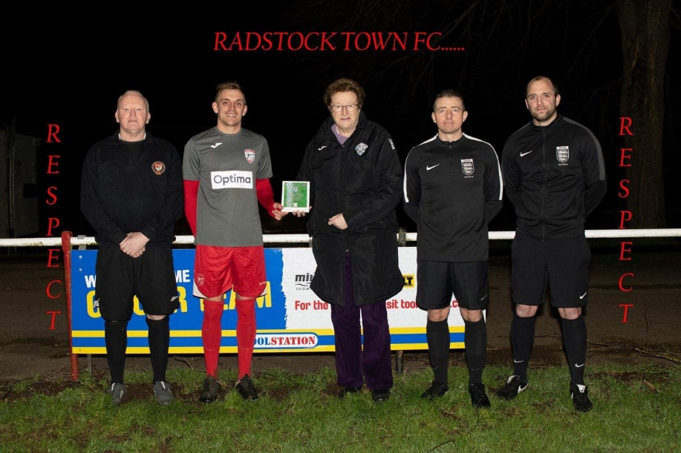
Awards Update
Radstock Town were presented with the Respect Award November to January by Western League Director Sue Merrill
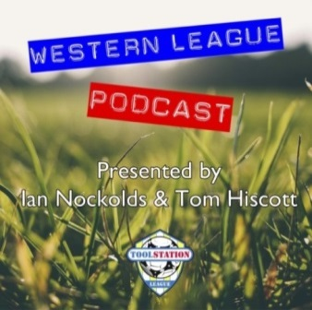

Be sure to check out the latest podcast, where Ian, Tom & guests recap all the latest news and results from around the Western League. To follow along all season, each broadcast will be available at the following link: http://www.toolstationleague.com/podcasts.php

Premier Division: Only four points separates the top six in the Premier Division, after leaders Plymouth Parkway relied on an injury-time goal to draw 2-2 with Hallen at Bolitho Park. Hallen’s long unbeaten run came to an end during the week, but they rebounded well away at the league leaders, storming into a two-goal lead at the interval. The deadlock was broken after just six minutes through Aaron Anglin, before Ed Bamfo doubled their advantage just before the break after reacting fastest to a loose ball in the home side’s six-yard box. An out of sorts Parkway were handed the chance to trim the deficit ten minutes into the second half, but Shane Krac spurned the opportunity from the penalty spot, ballooning his effort over the bar. Fortunately for Krac, his teammates didn’t wait long before making amends, with Adam Carter scoring after good work from Ryan Lane just after the hour mark. Hallen withstood plenty of pressure during the final half hour, and looked like they had grabbed a memorable victory, but the influential Lane had other ideas. After playing a major role in the earlier goal, Lane produced some excellence once more in the fourth minute of stoppage time, when his pin-point cross was headed home by Mike Landricombe to secure a dramatic point. Tavistock are now level on points with Parkway atop the division after a dominant second half performance saw them win 4-0 against Odd Down. The Bath side had shown signs of revival in recent times, and they kept their visitors at bay for the opening 45 minutes, but once Jack Crago had opened the scoring, the floodgates opened somewhat. Crago’s penalty put Tavy in front on the hour mark, and they didn’t look back after that, with further goals from Liam Prynn, Warren Daw and Josh Grant helping them secure a commanding victory. Another top side on the rise are Exmouth, and they eased to a 7-1 thrashing of Chipping Sodbury Town at the King George Ground. Goals in the opening quarter from Aaron Denny and Jordan Harris set Exmouth on their way, with Ben Steer, Callum Shipton and Dean Billingsley all joining them on the scoresheet during the one-sided affair. The in-form Jack Fillingham starred for Shepton Mallet once again, scoring twice in their 2-1 win over Westbury. Unfortunately for the Wiltshire side, it was a defensive mishap which allowed Fillingham to open the scoring, with the Shepton frontman capitalising on an error at the back to break the deadlock after an hour. 15 minutes later, Fillingham headed home a cross from Conrad Peck to double his tally, before Steve Hulbert grabbed a late consolation for the visitors. FA Vase semi-finalists Bitton continued their impressive run, winning 2-1 away at top-half opponents Clevedon Town. Oaklan Buck was the standout performer for Bitton at the Hand Stadium, and it was a volley from the former Bath City frontman who opened the scoring in the 14th minute. Things then took a turn for the worse Dan Langdon’s side, with Dan Ferguson drawing the hosts level, before Gerrard Robinson was given a straight red card in a bad five minute spell leading up to half time. Langdon’s charges have shown plenty of battling qualities recently, and they were important once more in a tough encounter, with the ten men managing to secure all three points, when Buck slotted the ball between the Town keeper’s legs midway through the second half.
On a day when they paid their respects to much-loved Chairman Roy Holmes, Buckland defeated Bridport by five goals to nil at Homer’s Heath. After an own goal from the visiting keeper helped Buckland go one ahead in the 14th minute, Ryan Bush then took over the game, scoring twice to give his side a three-goal advantage at the break. Athletic continued where they left off at the start of the second half, with Nathan Cooper powering home a header to make it 4-0, before Jamie Passmore completed the scoring late on.
Things were much tighter at Oaklands Park, where Roman Glass St George produced a second half fightback to defeat Cadbury Heath 2-1. The Heath came into the game on the back of a four-game losing run, but they put themselves in position to bring that to an end when Enis Akgun handed them an early lead. The Glass came from behind to beat Keynsham during the week, and they repeated the trick on Saturday, with Sam Wentland drawing them level in the early stages of the second half, before Ryan Radford completed the comeback in the closing stages. A late goal also decided the game in Somerset, where Brislington struck in stoppage time to defeat Wellington by the slimmest of margins. With a goalless draw looking like a certainty, Brislington had one final chance, and after packing the box, Simon Prangman’s free kick was met by the head of Scott Lewis to give the away side a dramatic winner.
Buckland and Bridport pay their respects to Roy Holmes ahead of kickoff at Homer’s Heath.
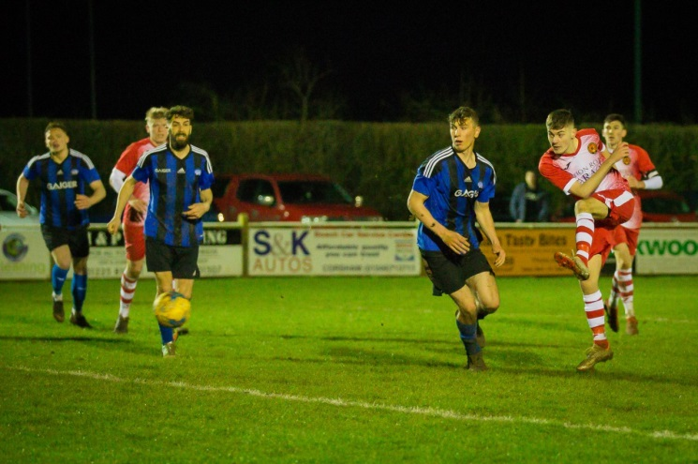
First Division: In front of a very healthy Friday night crowd at the Southbank Ground, Corsham defeated Wiltshire rivals Devizes 1-0 to maintain their unbeaten home run in 2020. In a repeat of the result between these two sides less than two months ago, one goal decided the outcome, with youngster Jake Dodge rising from the bench to secure the three points. The under-18 player entered the fray during the second half, striking the all-important goal 20 minutes from time, a couple of moments after the hosts had been reduced to ten men.
Action from Corsham’s Friday night victory in their Wiltshire derby, courtesy of John Cuthbertson.

In the clash which saw top take on bottom, Calne required an injury time winner to see off a gallant Bishop Sutton by three goals to two at Lakeview. In an incident-filled fixture, Bishop Sutton were thwarted in their attempts at taking an early lead, when visiting keeper Sam Thomson saved an eighth minute spot kick. Less than ten minutes later, the Lilywhites went ahead when the in-form Stuart Windsor added another goal to his impressive tally. The home side hit back on the half hour, before Calne restored their lead at the end of the first half thanks to a fine finish from Nathan Davis. The hosts proved tough to shake off however, and having already produced one mini comeback, they levelled the scores once again 20 minutes from time. That left the game evenly poised going into the final quarter, and it was Calne who managed to find the fifth and final goal. Having just had their keeper dismissed for handling the ball outside the area, Sutton hearts were broken in the second minute of stoppage time, when the ten men conceded to Jamal Chevolleau as Calne managed to maintain their lead atop the division by the skin of their teeth. It is now Sherborne Town who sit second in the table following a hard-fought 2-0 win away at Warminster. Following a goalless opening half, in which the home side had a number of opportunities to break the deadlock, it was the Zebras who produced two meaningful moments after the interval, with goals from Anthony Herrin and Sam Farthing helping them grab the crucial three points. The performance of the day belonged to Welton Rovers, with the new-look Green Army hitting Bristol Telephones for six at West Clewes. With four debutants, and a new management staff, Welton flew out of the blocks, leading after just 17 seconds thanks to one of those first time starters, Jacob Reader. Rene Adigbo and Liam Evans then scored in quick succession to extend the lead to three, before Sam Stoppard capped a perfect first half, when his left-footed corner ended up in the back of the Telephones net. Adigbo kept the ball rolling early in the second half when he took the Welton tally to five, with Chris Pile then completing the scoring in stoppage time on a perfect afternoon for the hosts. Hengrove Athletic have now won four of their last five in all competitions after upsetting title chasers Wells City 3-2 at Paprika Park. Wells themselves had won three on the spin heading into Saturday’s clash, and they made a fast start away from home, taking a ninth minute lead through Craig Herrod. Hengrove weren’t behind for long however, and less than five minutes later, Adrian Thompson struck to get them back on level terms, before both Pete Sheppard and Sam Payne then scored in quick succession to give the home side a commanding 3-1 lead. Wells had plenty of attacking options on the field, and they eventually pulled a goal back midway through the second half thanks to Harry Foster, but they were unable to pluck out an equaliser and suffered a rare defeat. There was also a surprising result at the Lancer Scott Stadium, where Ashton & Backwell United fell to a 2-0 defeat at home to Lebeq. Having won nine of their previous ten league fixtures, Ashton would have expected to see off a Lebeq side who suffered a shock 5-1 defeat against Bristol Telephones last weekend, but it wasn’t to be and the hosts have now dropped to fifth. Almondsbury put more ground between themselves and the bottom two after producing a fine performance away at Bishops Lydeard. A strong finish at the back post from Greg Parr set the Almonds on their way, with a pair of thunderous volleys from Geraint Williams and Stuart Alexander either side of the interval helping them secure a 3-0 win. Wincanton secured their second win this week, after a brace from Toby Dolton Cole in the early stages of the second half saw them defeat Portishead Town 2-1. Wincanton then suffered two red cards in the closing stages, before conceding to their visitors, but managed to keep them at bay to grab a 13th league win this term. In the top six clash at Shellards Road, the sides could not be separated, with Longwell Green Sports and Radstock Town battling out a 1-1 draw.

Western League Statistical Leaders

PREMIER DIVISION LEADING GOAL SCORERS (League only):
Adam Carter (Plymouth Parkway) – 29
Jack Fillingham (Shepton Mallet) – 23
Jordan Harris (Exmouth Town) – 23
Leighton Thomas (Street) – 18
Mikey Williams (Plymouth Parkway) – 17
Jack Taylor (Bridgwater Town) – 16
Neikell Plummer (Bradford Town & Brislington) - 16

PREMIER DIVISION TOP ATTENDANCES:
Plymouth Parkway 2 Tavistock 3, Thursday 26th December 2019 - 564
Bridport 0 Bridgwater Town 6, Sunday 6th October 2019 – 347
Wellington 0 Exmouth Town 2, Sunday 6th October 2019 - 315

FIRST DIVISION LEADING GOAL SCORERS (League only):
Harry Foster (Wells City) – 25
Stuart Windsor (Calne Town) – 20
James Rustell (Radstock Town) – 19
Toby Cole (Wincanton Town) – 14
Alex Murphy (Sherborne Town) – 14
Josh Bright (Corsham Town) – 13

FIRST DIVISION TOP ATTENDANCES:
Warminster Town 2 Bristol Telephones 3, Saturday 5th October 2019 - 369
Longwell Green Sports 1 Oldland Abbotonians 2, Saturday 28th December 2019 - 289
Portishead Town 3 Longwell Green Sports 5, Saturday 5th October 2019 – 262

LEADING SCORERS IN ALL COMPETITIONS:
Jack Crago (Tavistock) - 37
Harry Foster (Wells City) – 32
Adam Carter (Plymouth Parkway) – 29
Jack Fillingham (Shepton Mallet) – 28
Jordan Harris (Exmouth Town) - 26
James Rustell (Radstock Town) – 24
Jack Taylor (Bridgwater Town) – 23

*All goalscoring stats via Full-Time FA website

Latest Results
Tuesday 3rd March 2020
Premier Division
Bitton 3-0 Hallen 72
Brislington 4-4 Clevedon Town 78
Odd Down 3-4 Cribbs 56
Shepton Mallet 4-0 Exmouth Town 54
First Division
Almondsbury 1-3 Wincanton Town 27
Bristol Telephones 1-0 Cheddar 31
Radstock Town 1-3 Portishead Town 44
Wiltshire FA Senior Cup – Semi Final
Corsham Town 2-3 Bemerton Heath Harlequins
Wednesday 4th March 2020
Premier Division
Roman Glass St George 2-1 Keynsham Town 40
Tavistock 1-0 Bridgwater Town
Friday 6th March 2020
First Division
Corsham Town 1-0 Devizes Town 241
Saturday 7th March 2020
Premier Division
Buckland Athletic 5-0 Bridport 169
Clevedon Town 1-2 Bitton 124
Exmouth Town 7-1 Chipping Sodbury Town 194
Odd Down 0-4 Tavistock 42
Plymouth Parkway 2-2 Hallen 163
Roman Glass St George 2-1 Cadbury Heath 52
Shepton Mallet 2-1 Westbury United 131
Wellington 0-1 Brislington 45
First Division
Ashton & Backwell United 0-2 Lebeq United 81
Bishop Sutton 2-3 Calne Town 38
Bishops Lydeard 0-3 Almondsbury
Hengrove Athletic 3-2 Wells City 33
Longwell Green Sports 1-1 Radstock Town 74
Warminster Town 0-2 Sherborne Town 126
Welton Rovers 6-0 Bristol Telephones 71
Wincanton Town 2-1 Portishead Town 50

Upcoming Fixtures
Tuesday 10th March 2020
Premier Division
Chipping Sodbury Town vs Bitton 19:30KO
Hallen vs Bradford Town 19:30KO
Keynsham Town vs Street 19:45KO
Shepton Mallet vs Bridport 19:30KO
First Division
Almondsbury vs Corsham Town 19:30KO
Bristol Telephones vs Warminster Town 19:45KO
Cheddar vs Lebeq United 19:45KO
Hengrove Athletic vs Wincanton Town 19:30KO
Radstock Town vs Welton Rovers 19:30KO
Somerset FA Premier Cup – Quarter Final
Wells City vs Bridgwater Town 19:45KO
Wednesday 11th March 2020
Premier Division
Plymouth Parkway vs Westbury United 19:30KO
Roman Glass St George vs Buckland Athletic 19:30KO
Tavistock vs Wellington 19:30KO
First Division
Oldland Abbotonians vs Devizes Town 19:45KO
Devon FA St Lukes Bowl – Quarter Final
Willand Rovers vs Exmouth Town 19:45KO
Wiltshire FA Senior Cup – Semi Final
Calne Town vs Wroughton 19:45KO
Thursday 12th March 2020
Premier Division
Bitton vs Cribbs 19:30KO
Saturday 14th March 2020 (KICK OFF AT 3.00PM UNLESS NOTED)
Premier Division
Bitton vs Bridgwater Town
Bradford Town vs Wellington
Bridport vs Clevedon Town
Cadbury Heath vs Shepton Mallet
Cribbs vs Tavistock
Exmouth Town vs Brislington
Hallen vs Keynsham Town
Odd Down vs Street
Plymouth Parkway vs Roman Glass St George
Westbury United vs Buckland Athletic
First Division
Bristol Telephones vs Bishop Sutton
Calne Town vs Bishops Lydeard
Devizes Town vs Hengrove Athletic 14:00KO
Longwell Green Sports vs Warminster Town
Oldland Abbotonians vs Wincanton Town
Portishead Town vs Almondsbury
Radstock Town vs Ashton & Backwell United
Sherborne Town vs Cheddar
Wells City vs Corsham Town
League Tables
Premier Division
 |  | P | W | D | L | F | A | GD | PTS
1 | Plymouth Parkway | 23 | 19 | 2 | 2 | 80 | 21 | 59 | 59
2 | Tavistock | 25 | 19 | 2 | 4 | 70 | 29 | 41 | 59
3 | Bradford Town | 22 | 19 | 1 | 2 | 69 | 20 | 49 | 58
4 | Hallen | 29 | 17 | 6 | 6 | 64 | 48 | 16 | 57
5 | Exmouth Town | 25 | 18 | 2 | 5 | 64 | 26 | 38 | 56
6 | Shepton Mallet | 27 | 17 | 4 | 6 | 66 | 31 | 35 | 55
7 | Bitton | 25 | 16 | 2 | 7 | 68 | 34 | 34 | 50
8 | Bridgwater Town | 27 | 13 | 7 | 6 | 65 | 40 | 25 | 46
9 | Clevedon Town | 29 | 12 | 5 | 12 | 58 | 62 | -4 | 41
10 | Street | 29 | 12 | 4 | 13 | 60 | 63 | -3 | 40
11 | Westbury United | 28 | 12 | 3 | 13 | 53 | 42 | 11 | 39
12 | Buckland Athletic | 24 | 12 | 2 | 10 | 48 | 47 | 1 | 38
13 | Roman Glass St George | 28 | 11 | 4 | 13 | 61 | 47 | 14 | 37
14 | Brislington | 27 | 10 | 5 | 12 | 42 | 62 | -20 | 35
15 | Keynsham Town | 28 | 10 | 4 | 14 | 48 | 56 | -8 | 34
16 | Cribbs | 27 | 8 | 3 | 16 | 37 | 66 | -29 | 27
17 | Cadbury Heath | 30 | 6 | 7 | 17 | 34 | 78 | -44 | 25
18 | Bridport | 27 | 5 | 2 | 20 | 35 | 90 | -55 | 17
19 | Chipping Sodbury Town | 27 | 5 | 1 | 21 | 30 | 91 | -61 | 16
20 | Wellington | 29 | 3 | 3 | 23 | 24 | 70 | -46 | 12
21 | Odd Down | 28 | 3 | 1 | 24 | 26 | 79 | -53 | 10

First Division
 |  | P | W | D | L | F | A | GD | PTS
1 | Calne Town | 26 | 18 | 2 | 6 | 47 | 21 | 26 | 56
2 | Sherborne Town | 25 | 17 | 2 | 6 | 58 | 33 | 25 | 53
3 | Longwell Green Sports | 27 | 16 | 4 | 7 | 64 | 38 | 26 | 52
4 | Wells City | 26 | 15 | 6 | 5 | 67 | 30 | 37 | 51
5 | Ashton & Backwell United | 26 | 15 | 6 | 5 | 42 | 39 | 3 | 51
6 | Radstock Town | 23 | 14 | 3 | 6 | 53 | 32 | 21 | 45
7 | Corsham Town | 26 | 13 | 3 | 10 | 44 | 50 | -6 | 42
8 | Wincanton Town | 23 | 13 | 2 | 8 | 47 | 46 | 1 | 41
9 | Oldland Abbotonians | 21 | 10 | 5 | 6 | 29 | 32 | -3 | 35
10 | Cheddar | 24 | 10 | 4 | 10 | 38 | 37 | 1 | 34
11 | Bishops Lydeard | 23 | 10 | 3 | 10 | 48 | 38 | 10 | 33
12 | Lebeq United | 27 | 11 | 1 | 15 | 52 | 62 | -10 | 33
13 | Portishead Town | 26 | 9 | 4 | 13 | 45 | 46 | -1 | 31
14 | Hengrove Athletic | 25 | 9 | 4 | 12 | 24 | 48 | -24 | 31
15 | Almondsbury | 24 | 8 | 4 | 12 | 35 | 40 | -5 | 28
16 | Warminster Town | 24 | 8 | 2 | 14 | 41 | 40 | 1 | 26
17 | Welton Rovers | 25 | 7 | 4 | 14 | 33 | 44 | -11 | 25
18 | Devizes Town | 25 | 3 | 6 | 16 | 33 | 56 | -23 | 15
19 | Bristol Telephones | 25 | 4 | 2 | 19 | 34 | 70 | -36 | 14
20 | Bishop Sutton | 25 | 3 | 3 | 19 | 27 | 59 | -32 | 12

